Line and power for ancillaries
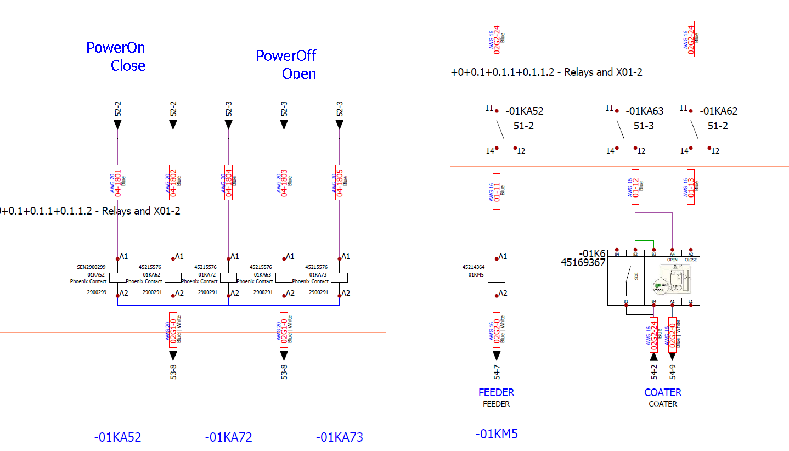
For Motorized Switches, fist activate Open to avoid Power OFF and later Activate Close to Power ON
For Contactors, activate directly

